RESOURCES AND READINGS

Unit One: Prehistory

Reading Packet One:
“The Myth-Making Outlook of the Ancient Near East” –Perry: Sources of the Western Tradition, p 15.
“Personification of Natural Objects” Sources, p 16.
“Enuma Elish” –The Babylonian Genisis, Sources, p 16-17.
Reading Packet Two:
Introduction/ The Purpose of Myths/ The Matriarchal Society/ Academic Perspectives on Myths” World Mythology- Rosenberg, p xv – xxii.
“Telepinu” – Hittite nature myth World Mythology, p 168 – 172.
“Great Medicine Makes a Beautiful Country,” American Indian Myths and Legends – Erdos and Ortiz, p 11-113.
Textbook:
“Chapter 1: Prehistory” Discovering the Humanities, p 1-15.
Key Terms:
Bipedal, cromlech, megalithic, menhir, metaphor, narrative sequence, natural selection, naturalistic, post-and-lintel, prehistory, shaman, trilithon
Key Questions:
What does the evidence of human prehistory in the Upper Paleolithic era demonstrate about humanity’s first ceremonies or rituals? What arguments can be made for man’s capacity to think symbolically, and why is symbolic thinking important to what it means to be human?
What are the characteristics of cave art? Which of these traits qualify as naturalistic? Can cave art be construed as “narrative?” How does narrative contribute to the human concept of culture?
What artifacts and myths pertain to your identification with “culture” here and now, as an American teenager? Ethnic group? Student at Arvada High School? Member of a club or sport? Member of your family clan?
Essential Question: What is it about narrative and symbolic thinking that is so important to being human in terms of evolution and human development? Video: Lionel Tiger- Religion and serotonin.

Unit One JIGSAW GROUPING for discussion and RESEARCH:
Group A: Artifacts- Scientists
Group B: Myths and Symbols - Mystics
Music: “Leylet Arghool” (Ancient Reeded Flutes driven by Folkloric Drums- Michael Beach
“Ancestor Song” Music for The Native Americans – Robbie Robertson
“Flute Clan Gathering” Ritual Mesa -Native Flute Ensemble
“Sibi Saba” African Tribal Music and Dances – Tribal Music on Location (Sonar Senghor)
“Sindhio” African Tribal Music and Dances – Tribal Music on Location (Sonar Senghor)
“Shaman’s Initiation” Ancient Earth Mantra- The Healing Drum
Location - Rhapsody Playlist: Humanities - Rhapsody.com
WebQuest links for POI:

Sample Formative Assessment: Unit One- Prehistory.

About 500,000 years ago, the first true human - homo sapiens - evolved in what is now
Egypt and Mesopotamia.
China and Indonesia.
France and Germany.
Africa and Asia.

One of the first important steps that advanced the evolution of humans was the
making of tools.
control of fire.
acquisition of language.
development of bipedalism.

The abilities to construct language, invent technology, tell stories and create myths are all part of this important characteristic that separates humans from other species:
Creative arts.
Metaphor.
Symbolic thinking.
Narrative sequence.

It is believed that the cave paintings in Lascaux, France may have been part of a hunting ritual because in comparison to the human figures in the caves, the animals are
more naturalistic.
smaller.
larger.
more abstract.

The advancement of humans was facilitated, in part, by the ability to create and understand this, which is a comparison in which one thing stands for another.
Metaphor
Language
Art
Technology

In the eras of human development known as Paleolithic, Mesolithic, and Neolithic, the syllable "lith" means
cave.
stone.
writing.
man.

An important figure in most hunting and gathering societies is the
hunter.
physician.
shaman.
fortune teller.

The Neolithic sacred site known as Stonehenge is constructed using a building system of two vertical stones supporting a horizontal one. This is known as
barrel vault.
megalith.
post-and-lintel.
concentric circles.

Unit One Vocabulary Quiz: Adams

Additional POI web sources:

Witt Resource Website: Timeline link
75,000 BCE – Present: Ornamentation, Burial Ritual and Tool Making
Blombos Cave Beads website link and image:
http://www.nsf.gov/news/news_summ.jsp?cntn_id=100362&org=NSF&from=news
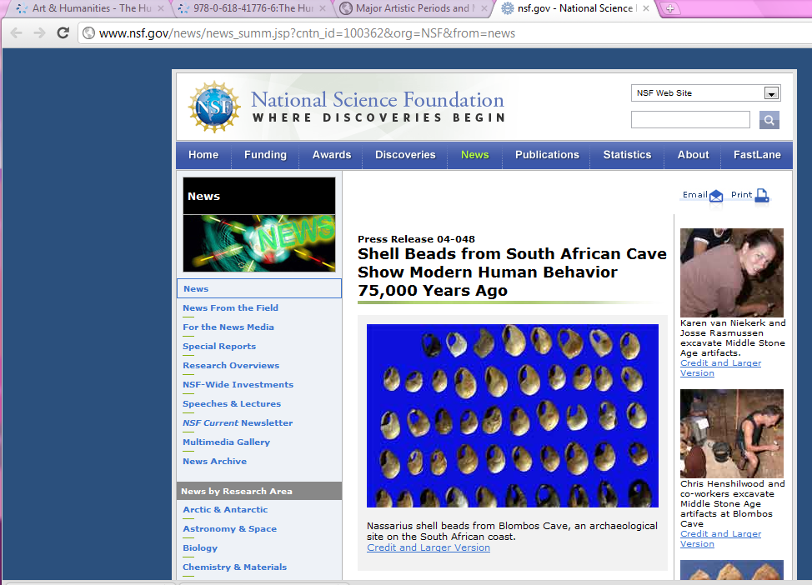
April 15, 2004
ARLINGTON, Va.—Perforated shells found at South Africa's Blombos Cave appear to have been strung as beads about 75,000 years ago—making them 30,000 years older than any previously identified personal ornaments. Archaeologists excavating the site on the coast of the Indian Ocean discovered 41 shells, all with holes and wear marks in similar positions, in a layer of sediment deposited during the Middle Stone Age (MSA).
"The Blombos Cave beads present absolute evidence for perhaps the earliest storage of information outside the human brain," says Christopher Henshilwood, program director of the Blombos Cave Project and professor at the Centre for Development Studies of the University of Bergen in Norway.
The shells, found in clusters of up to 17 beads, are from a tiny mollusk scavenger, Nassarius kraussianus, which lives in estuaries. They must have been brought to the cave site from the nearest rivers, 20 kilometers east or west on the coast. The shells appear to have been selected for size and deliberately perforated, suggesting they were made into beads at the site or before transport to the cave. Traces of red ochre indicate that either the shell beads themselves or the surfaces against which they were worn were coated with this widely used iron oxide pigment.
A few years ago, Blombos excavators found chunks of inscribed ochre and shaped bone tools that challenged the then-dominant theory of behavioral evolution, which held that humans were anatomically modern at least 160,000 years ago but didn't develop critical modern behaviors until some punctuating event 40,000 or 50,000 years ago. Henshilwood and his colleagues (including Francesco d'Errico and Marian Vanhaeren of the University of Bordeaux, France, and Karen van Niekerk of the University of Bergen) believe the Blombos bone tools and ochre show that modern behavior like the use of external symbols developed gradually throughout the Middle Stone Age, not suddenly when our ancestors spread from Africa to Eurasia.
-NSF-
Ochre and bone tool findings at Blombos Cave are described in an earlier NSF press release:http://www.nsf.gov/od/lpa/news/02/pr0202.htm.
Under the TIMELINE link on the Witt web site: 30,000 BCE – Narrative, Symbol and living ritual.
Students who click on the “30,000 BC, Chauvet Cave, France Cave Paintings” link are taken to the following web source:
Link: http://www.culture.gouv.fr/culture/arcnat/chauvet/en/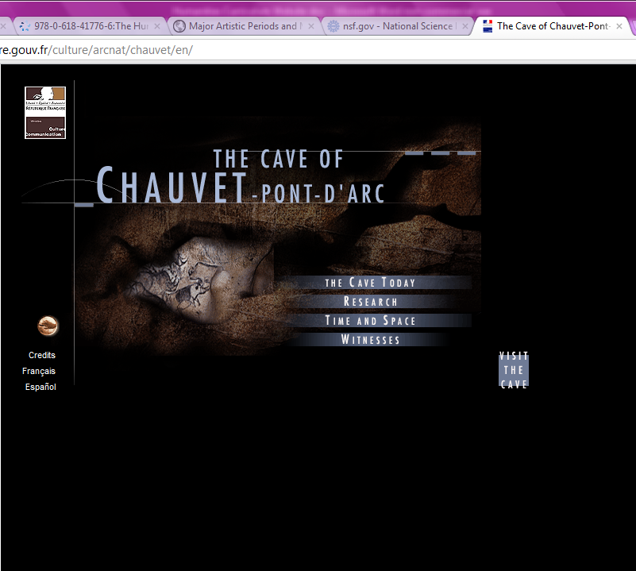

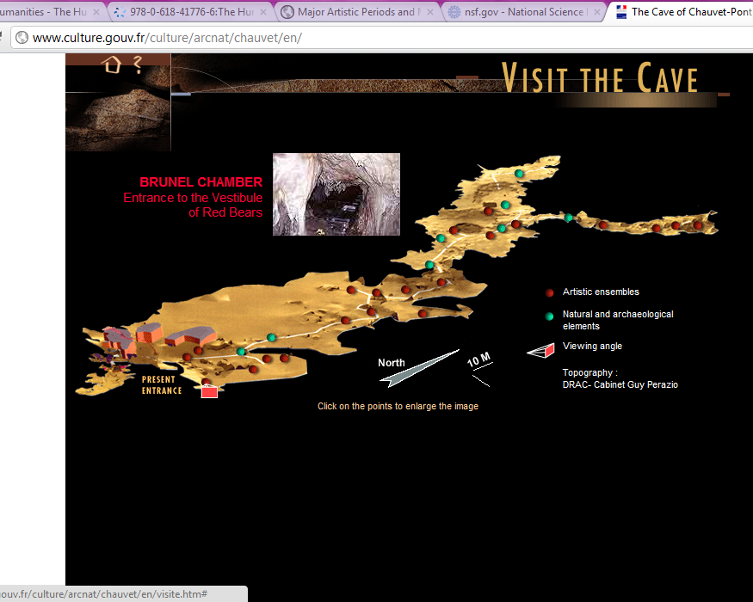
The Hermitage Link: Russian Figurines c. 22,000 BCE
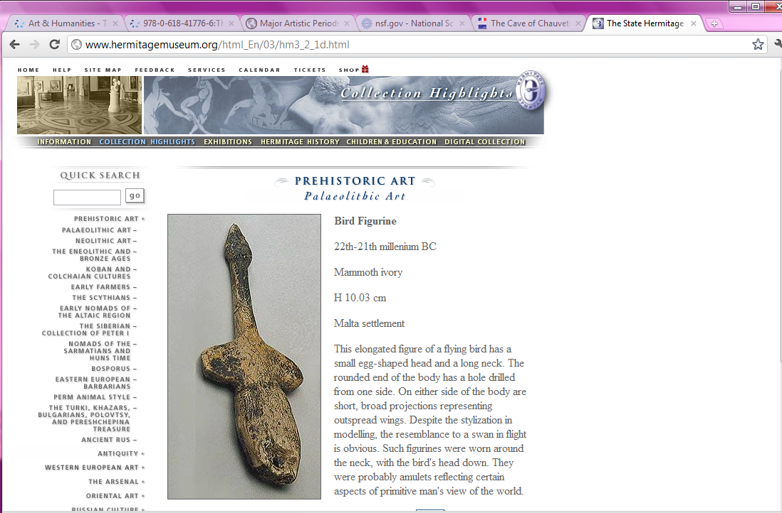
Supplementary Questions from the Witt Text for One Page Response:
Use and cite at least one of the art pieces, texts or artifacts discussed in class to answer one of the following questions:
If someone came up to you and asked you to explain what a shaman is, how would you respond? What do fire, dreams and animal representations have to do with it?
What is bipedalism? What do you think is the most important result of it? Why? What are some of its consequences?
The third main Stone Age period in Western Europe is known as the Neolithic Era. What significantly differentiates this era from those previous? Include in your discussion the relevance of agriculture and uses for stone and copper.
What evidence exists to make an argument that humans used symbolic thinking or narrative before 40 – 30,000 BCE?

